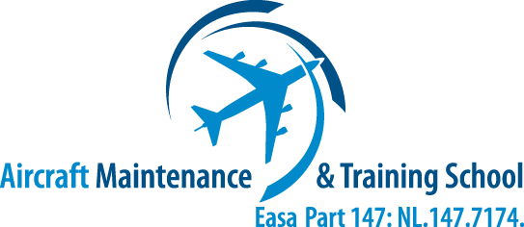
News
  - AM&TS releases Online Training Platform for training and examination

Hoogerheide (NL), June 1st, 2015

AM&TS has launched an Online Training Platform. The Platform started off with; Continuation Training courses in Human Factors, Fuel Tank Safety, EWIS (1 to 5) as well as examinations. Using this platform, aviation maintenance staff can keep their skills up to speed with the latest certifications and criteria required in the industry.

Online training opens up new opportunities to train employees at work, at home or anywhere in the word, since there are no limitations as to where or when the course can be taken. This opens up new possibilities for AM&TS to also access the most remote areas of the global market. “With the possibility to participate in an open forum discussion we are able to continuously improve our courseware to the customer’s specific needs”, says Wim Blinkhof, General Manager at AM&TS. “From now on we will continue to grow our online training portfolio. By doing this we respond to the high demand of the current market. Together with customized training, such as a specific portfolio in composite maintenance and examination we can offer training at a lower rate than traditional in-house (class room) training”.

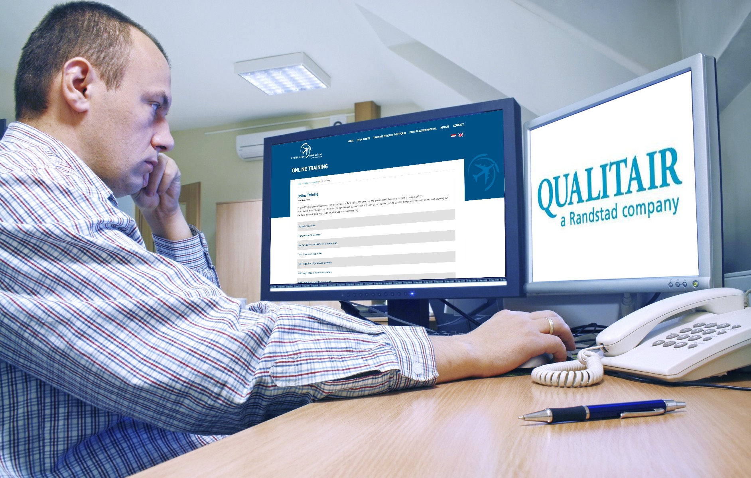
The Qualitair Aviation Group (aviation recruitment and project specialist) will be the first to use the online platform to keep their employees current. “As a worldwide recruitment organization, this Part 147 certified online training provides our workforce around the world the best support in their constant need to stay compliant with the latest regulations, says Frans de Vries, Managing Director at Qualitair Holland The Online Platform under the Part 147 certification of AM&TS is a result of the continuous support, evolvement and personal dedication to its customers. In this way Qualitair is able to keep its technical staff, Licensed and Un-Licensed, from all over the world current, at all times. An up-to-date training overview of all the staff is available in seconds and swiftly can be transferred to our staff and clients. This platform offers us the possibility to certify staff both quickly and at the required highest possible level and thus a maximum service to our clients quality organisation and to the aviation authorities.”

AM&TS trains technicians for the aviation sector by providing education and training for both students at the outset of their careers as well as professionals based on the EASA Part 147 certification. Educational programmes contribute to the success of organisations and their staff. The online training platform benefits well qualified aviation technicians and thus to a safe and future proof aviation sector.

“Not only recurrent training, but being able to measure the level of technical understanding and insight of complicated maintenance issues will become of high importance in the near future of aviation training”, says De Vries.

Visit the platform: http://am-ts.nl/online-training
Contact us: +31(0)88 929 9000 or info@am-ts.eu

